**E-COMMERCE WEBSITE**

**ABSTRACT**

The e-commerce website project is a simplified platform designed to simulate the basic functionalities of an online shopping system. It focuses on providing a user-friendly interface for browsing products, managing a shopping cart and placing orders, etc. The website includes essential features such as user registration and login, Product listing by categories, and a wish list for the users to add items which are not available at the moment.

The database is designed with 9 tables to manage critical aspects of the system, including user data, product details, categories, orders, payments, inventory, cart, reviews and wish list for customers. For example, the products table stores information about available items, while the users table keeps track of customer login credentials. The orders table records placed orders, and the inventory table ensures accurate stock updates.

This project highlights the integration of a basic web interface with a structured database, offering a foundation for understanding e-commerce systems. It is intended as a learning project to explore database design, web development basics, and the flow of data in an online store.

**ER DIAGRAM**

**Entities and Attributes: -**

1)User: - { user_id, ph_no, address, name, date of birth, age, password}

2)Products: - {Product_id, Product name, Price, Quantity}

3) Cart: - {Product_id, Product name, cart total}

4)Orders: - {Order_id, Price, quantity, product name, order date}

5)Supplier: - {Supplier_id, product_id, product name, Contact info, Supplier Address}

6)Category: - {Category_id, Category name, description}

7) Wish List: - { Product_id, Product name, Quantity}

8)Reviews: - {review_id, product_id, user_id, rating}

9)Payments: - {Payment_id, Amount, Payment methods, order_id}

1. User: -

|  |  |  |  |  |  |  |  |  |
| --- | --- | --- | --- | --- | --- | --- | --- | --- |
| User_id | First name | Middle name | Last name | Date of birth | Age | Ph no | Address | Password |
|  |  |  |  |  |  |  |  |  |
|  |  |  |  |  |  |  |  |  |
|  |  |  |  |  |  |  |  |  |

1. Products: -

|  |  |  |  |
| --- | --- | --- | --- |
| Product_id | Product name | quantity | price |
|  |  |  |  |
|  |  |  |  |
|  |  |  |  |

1. Cart: -

|  |  |  |
| --- | --- | --- |
| Product_id | Product name | Cart total |
|  |  |  |
|  |  |  |
|  |  |  |

1. Orders: -

|  |  |  |  |  |
| --- | --- | --- | --- | --- |
| Order_id | Price | quantity | Product name | Order date |
|  |  |  |  |  |
|  |  |  |  |  |
|  |  |  |  |  |

1. Supplier: -

|  |  |  |  |  |
| --- | --- | --- | --- | --- |
| Supplier_id | Product_id | Product name | Contact info | Supplier address |
|  |  |  |  |  |
|  |  |  |  |  |
|  |  |  |  |  |

1. Category: -

|  |  |  |
| --- | --- | --- |
| Category_id | Category name | Discription |
|  |  |  |
|  |  |  |
|  |  |  |

1. Wish List: -

|  |  |  |
| --- | --- | --- |
| Product_id | Product name | quantity |
|  |  |  |
|  |  |  |
|  |  |  |

1. Review: -

|  |  |  |  |
| --- | --- | --- | --- |
| Review_id | User_id | Product name | Rating |
|  |  |  |  |
|  |  |  |  |
|  |  |  |  |

1. Payments: -

|  |  |  |  |
| --- | --- | --- | --- |
| Payment_id | Payment methods | Order_id | Amount |
|  |  |  |  |
|  |  |  |  |
|  |  |  |  |

**Relational Algebra: -**

**Table 1: User (User_ID, Name, Phone_No, Address, DOB, Age, Password)**

**Retrieve all users who live in "New York"**

σAddress=′NewYork′​(User)

**Find all users and suppliers who are from "New York."**

πUser_ID,Name,Address​(σAddress=′NewYork′​(User)) ∪ πSupplier_ID,Name,Address​(σAddress=′NewYork′​(Supplier))

**Find users who have the same age**

σAge>30​(User)

**List all user IDs and their names**

πUser_ID,Name​(User)

**Find users who have the same age**

ρU1​(User)⋈U1.Age=U2.Age​ρU2​(User)

**Find all users who have added a product to their cart and also ordered the same product**

πUser_ID,Product_ID,Product_Name​(Orders) ∩ πUser_ID,Product_ID,Product_Name​(Cart)

**Table 2: Products (Product_ID, Product_Name, Price, Quantity)**

**Retrieve all products that cost more than $1000**

σPrice>1000​(Products)

**Find products with the lowest price**

σPrice=MIN(Price)​(Products)

**Find the average price of all products**

gAVG(Price)​(Products)

**Find all products that are either in the cart or have been ordered.**

πProduct_ID,Product_Name​(Cart) ∪ πProduct_ID,Product_Name​(Orders)

**Table 3: Cart (Product_ID, Product_Name, Cart_Total)**

**Retrieve all products in the cart where total value exceeds $5000**

σCart_Total>5000​(Cart)

**List all product names from the cart**

πProduct_Name​(Cart)

**Find total cart value for all users**

gSUM(Cart_Total)​(Cart)

**Table 4: Orders (Order_ID, Price, Quantity, Product_Name, Order_Date)**

**Retrieve all orders placed after '2024-01-01'**

σOrder_Date>′2024−01−01′​(Orders)

**Find total revenue from orders**

gSUM(Price×Quantity)​(Orders)

**Find users who have not placed any orders**

πUser_ID​(User)−πUser_ID​(Orders)

**Table 5: Supplier (Supplier_ID, Product_ID, Product_Name, Contact_Info, Supplier_Address)**

**Retrieve all suppliers located in 'California'**

σSupplier_Address=′California′​(Supplier)

**Find suppliers that supply more than 5 products**

gSupplier_ID,COUNT(Product_ID)>5​(Supplier)

**Table 6: Category (Category_ID, Category_Name, Description)**

**Retrieve all categories that contain 'Electronics’**

σCategory_=′Electronics′​(Category)

**List all category names**

πCategory_Name​(Category)

**Table 7: Wish List (User_ID, Product_ID, Product_Name, Quantity)**

**Retrieve all products in the wishlist of user ID = 101**

σRating>4​(Reviews)

**List all unique product names in wishlists**

πProduct_Name​(WishList)

**Table 8: Reviews (Review_ID, Product_ID, User_ID, Rating)**

**Retrieve all reviews where the rating is greater than 4**

σRating>4​(Reviews)

**Find the highest-rated product**

σRating=MAX(Rating)​(Reviews)

**Table 9: Payments (Payment_ID, Amount, Payment_Methods, Order_ID)**

**Retrieve all payments made using "Credit Card"**

σPayment_Methods=′CreditCard′​(Payments)

**Find the total amount paid for all orders**

gSUM(Amount)​(Payments)

**Tuple Relational Calculus**

**Table 1: User**

**Retrieve all users who live in "New York"**

{U∣U∈User∧U.Address=′NewYork′}

**Find users older than 30 years**

{U∣U∈User∧U.Age>30}

**Table 2: Products**

**Retrieve all products that cost more than $1000**

{P∣P∈Products∧P.Price>1000}

**Find products that are out of stock**

{P∣P∈Products∧P.Quantity=0}

**Table 3: Cart**

**Retrieve all products in the cart where total value exceeds $5000**

σCart_Total>5000​(Cart)

**Table 4: Orders**

**Retrieve all orders placed after '2024-01-01'**

{O∣O∈Orders∧O.Order_Date>′2024−01−01′}

**Find users who have placed at least one order**

{U∣U∈User∧∃O∈Orders(U.User_ID=O.User_ID)}

**Table 5: Supplier**

**Retrieve all suppliers located in 'California'**

{S∣S∈Supplier∧S.Supplier_Address=′California′}

**Table 6: Category**

**Retrieve all categories that contain 'Electronics'**

{C∣C∈Category∧C.Category_Name=′Electronics′}

**Table 7: Wish List**

**Retrieve all wishlist items for user ID 101**

{W∣W∈WishList∧W.User_ID=101}

**Table 8: Reviews**

**Retrieve all reviews where the rating is greater than 4**

{R∣R∈Reviews∧R.Rating>4}

**Table 9: Payments**

**Retrieve all payments made using "Credit Card"**

{P∣P∈Payments∧P.Payment_Methods=′CreditCard′}

**Domain Relational Calculus**

**Table 1: User (User_ID, Name, Phone_No, Address, DOB, Age, Password)**

**Retrieve all users who live in "New York"**

{⟨UI​D,N,P,A,D,Ag,Pw⟩∣∃U(U∈User∧A=′NewYork′)}

**Find users who are older than every other user**

{⟨UI​D,N⟩∣UI​D∈User∧∀U2​∈User(UI​D!=U2​⇒Age>U2​.Age)}

**Table 2: Products (Product_ID, Product_Name, Price, Quantity)**

**Retrieve all products that cost more than $1000**

{⟨PI​D,PN​ame,Pr,Q⟩∣PI​D∈Products∧Pr>1000}

**Find products that are out of stock**

{⟨PI​D,PN​ame⟩∣PI​D∈Products∧Q=0}

**Table 3: Cart (Product_ID, Product_Name, Cart_Total)**

**Retrieve all cart items where total value exceeds $5000**

{⟨PI​D,PN​ame,CT​⟩∣PI​D∈Cart∧CT​>5000}

**Find users who have at least one item in the cart but have never ordered that item**

{⟨UI​D⟩∣∃C(C∈Cart∧C.UI​D=UI​D)∧¬∃O(O∈Orders∧O.PI​D=C.PI​D)}

**Table 4: Orders (Order_ID, Price, Quantity, Product_Name, Order_Date)**

**Retrieve all orders placed after '2024-01-01'**

{⟨OI​D,Pr,Q,PN​ame,OD​ate⟩∣OI​D∈Orders∧OD​ate>′2024−01−01′}

**Find users who have placed at least one order**

{⟨UI​D⟩∣∃O(O∈Orders∧O.UI​D=UI​D)}

**Table 5: Supplier (Supplier_ID, Product_ID, Product_Name, Contact_Info, Supplier_Address)**

**Retrieve all suppliers located in 'California'**

{⟨SI​D,PI​D,PN​ame,CI​nfo,SA​ddr⟩∣SI​D∈Supplier∧SA​ddr=′California′}

**Find suppliers who supply at least one product costing more than $500**

{⟨SI​D⟩∣∃P(P∈Products∧P.PI​D=SI​D∧P.Price>500)}

**Table 6: Category (Category_ID, Category_Name, Description)**

**Retrieve all categories that contain 'Electronics'**

{⟨CI​D,CN​ame,Desc⟩∣CI​D∈Category∧CN​ame=′Electronics′}

**Find categories that have no products assigned**

{⟨CI​D⟩∣CI​D∈Category∧¬∃P(P∈Products∧P.CI​D=CI​D)}

**Table 7: Wish List (User_ID, Product_ID, Product_Name, Quantity)**

**Retrieve all wishlist items for user ID 101**

{⟨PI​D,PN​ame,Q⟩∣PI​D∈WishList∧UI​D=101}

**Find users who have the same wishlist items**

{⟨U1​,U2​⟩∣∃W1​,W2​(W1​∈WishList∧W2​∈WishList∧W1​.PI​D=W2​.PI​D∧W1​.UI​D!=W2​.UI​D)}

**Table 8: Reviews (Review_ID, Product_ID, User_ID, Rating)**

**Retrieve all reviews where the rating is greater than 4**

{⟨RI​D,PI​D,UI​D,R⟩∣RI​D∈Reviews∧R>4}

**Find products that have only been rated 5 stars**

{⟨PI​D⟩∣∀R(R∈Reviews∧R.PI​D=PI​D⇒R.Rating=5)}

**Table 9: Payments (Payment_ID, Amount, Payment_Methods, Order_ID)**

**Retrieve all payments made using "Credit Card"**

{⟨PI​D,A,PM,OI​D⟩∣PI​D∈Payments∧PM=′CreditCard′}

**Find orders that have not yet been paid for**

{⟨OI​D⟩∣OI​D∈Orders∧¬∃P(P∈Payments∧P.OI​D=OI​D)}

**DDL (Data Definition Language) Queries:**

1. Create commands

CREATE TABLE user (

userid INT PRIMARY KEY AUTO_INCREMENT,

first_name VARCHAR(50),

middle_name VARCHAR(50),

last_name VARCHAR(50),

phoneno VARCHAR(15), -- Assuming it's stored as a string

date_of_birth DATE,

age INT, -- This will be manually calculated

address VARCHAR(255)

);

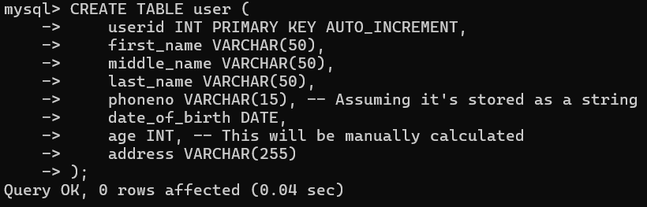

CREATE TABLE category (

category_id INT PRIMARY KEY AUTO_INCREMENT,

category_name VARCHAR(100),

description TEXT

);

CREATE TABLE product (

product_id INT PRIMARY KEY AUTO_INCREMENT,

product_name VARCHAR(100),

quantity INT,

price DECIMAL(10, 2),

category_id INT,

FOREIGN KEY (category_id) REFERENCES category(category_id)

);

CREATE TABLE orders (

order_id INT PRIMARY KEY AUTO_INCREMENT,

price DECIMAL(10, 2),

order_date DATE,

product_name VARCHAR(100),

quantity INT,

user_id INT,

FOREIGN KEY (user_id) REFERENCES user(userid)

);

CREATE TABLE payments (

payment_id INT PRIMARY KEY AUTO_INCREMENT,

payment_method VARCHAR(50),

amount DECIMAL(10, 2),

order_id INT,

FOREIGN KEY (order_id) REFERENCES orders(order_id)

);

CREATE TABLE reviews (

review_id INT PRIMARY KEY AUTO_INCREMENT,

product_name VARCHAR(100),

user_id INT,

rating INT CHECK (rating BETWEEN 1 AND 5),

FOREIGN KEY (user_id) REFERENCES user(userid)

);

CREATE TABLE cart (

cart_id INT PRIMARY KEY AUTO_INCREMENT,

cart_total DECIMAL(10, 2),

product_name VARCHAR(100),

product_id INT,

user_id INT,

FOREIGN KEY (product_id) REFERENCES product(product_id),

FOREIGN KEY (user_id) REFERENCES user(userid)

);

CREATE TABLE supplier (

supplier_id INT PRIMARY KEY AUTO_INCREMENT,

contact_info VARCHAR(100),

product_id INT,

product_name VARCHAR(100),

supplier_address VARCHAR(255),

FOREIGN KEY (product_id) REFERENCES product(product_id)

);

CREATE TABLE wishlist (

wishlist_id INT PRIMARY KEY AUTO_INCREMENT,

product_id INT,

product_name VARCHAR(100),

quantity_needed INT,

user_id INT,

FOREIGN KEY (product_id) REFERENCES product(product_id),

FOREIGN KEY (user_id) REFERENCES user(userid)

);

1. INSERT INTO commands:

INSERT INTO user (first_name, middle_name, last_name, phoneno, date_of_birth, age, address)

VALUES

('John', 'Doe', 'Smith', '1234567890', '1995-05-15', 30, '123 Main St, City, Country'),

('Alice', 'Marie', 'Johnson', '2345678901', '1987-07-22', 38, '456 Oak St, City, Country'),

('Bob', 'L', 'Williams', '3456789012', '2000-02-11', 25, '789 Pine St, City, Country'),

('Eve', 'S', 'Brown', '4567890123', '1990-11-09', 35, '101 Maple St, City, Country'),

('Charlie', 'B', 'Davis', '5678901234', '1992-03-29', 33, '202 Birch St, City, Country');

INSERT INTO category (category_name, description)

VALUES

('Electronics', 'Devices and gadgets like phones, laptops, etc.'),

('Clothing', 'Apparel for men, women, and children'),

('Home Appliances', 'Electrical appliances for home use'),

('Sports', 'Sports equipment and accessories'),

('Books', 'Physical and e-books for all genres');

INSERT INTO product (product_name, quantity, price, category_id)

VALUES

('Smartphone', 100, 499.99, 1),

('T-shirt', 200, 19.99, 2),

('Washing Machine', 50, 299.99, 3),

('Soccer Ball', 150, 25.99, 4),

('Java Programming Book', 300, 29.99, 5);

INSERT INTO orders (price, order_date, product_name, quantity, user_id)

VALUES

(499.99, '2025-03-01', 'Smartphone', 1, 1),

(19.99, '2025-03-02', 'T-shirt', 2, 2),

(299.99, '2025-03-03', 'Washing Machine', 1, 3),

(25.99, '2025-03-04', 'Soccer Ball', 3, 4),

(29.99, '2025-03-05', 'Java Programming Book', 5, 5);

INSERT INTO payments (payment_method, amount, order_id)

VALUES

('Credit Card', 499.99, 1),

('PayPal', 39.98, 2),

('Bank Transfer', 299.99, 3),

('Debit Card', 77.97, 4),

('Credit Card', 149.95, 5);

INSERT INTO reviews (product_name, user_id, rating)

VALUES

('Smartphone', 1, 5),

('T-shirt', 2, 4),

('Washing Machine', 3, 5),

('Soccer Ball', 4, 3),

('Java Programming Book', 5, 5);

INSERT INTO cart (cart_total, product_name, product_id, user_id)

VALUES

(499.99, 'Smartphone', 1, 1),

(39.98, 'T-shirt', 2, 2),

(299.99, 'Washing Machine', 3, 3),

(77.97, 'Soccer Ball', 4, 4),

(149.95, 'Java Programming Book', 5, 5);

INSERT INTO supplier (contact_info, product_id, product_name, supplier_address)

VALUES

('supplier1@electronics.com', 1, 'Smartphone', '123 Electronics St'),

('supplier2@clothing.com', 2, 'T-shirt', '456 Apparel Ave'),

('supplier3@appliances.com', 3, 'Washing Machine', '789 Appliance Rd'),

('supplier4@sports.com', 4, 'Soccer Ball', '101 Sports Blvd'),

('supplier5@books.com', 5, 'Java Programming Book', '202 Book Lane');

INSERT INTO wishlist (product_id, product_name, quantity_needed, user_id)

VALUES

(1, 'Smartphone', 1, 1),

(2, 'T-shirt', 2, 2),

(3, 'Washing Machine', 1, 3),

(4, 'Soccer Ball', 3, 4),

(5, 'Java Programming Book', 5, 5);

1. DELETE command

DELETE FROM wishlist WHERE user_id = 1 AND product_id = 1;



DELETE FROM cart WHERE user_id = 2 AND product_id = 2;



DELETE FROM reviews WHERE review_id = 1;



DELETE FROM payments WHERE payment_id = 2;



DELETE FROM reviews WHERE review_id = 2;



DELETE FROM wishlist WHERE user_id = 1;



DELETE FROM cart WHERE user_id = 1;



DELETE FROM reviews WHERE user_id = 1;



DELETE FROM orders WHERE user_id = 1;



DELETE FROM payments WHERE order_id IN (SELECT order_id FROM orders WHERE user_id = 1);



1. DROP command

CREATE TABLE customer_feedback (

feedback_id INT PRIMARY KEY AUTO_INCREMENT,

product_id INT,

user_id INT,

rating INT,

comments TEXT,

feedback_date DATE,

FOREIGN KEY (product_id) REFERENCES product(product_id),

FOREIGN KEY (user_id) REFERENCES user(userid)

);

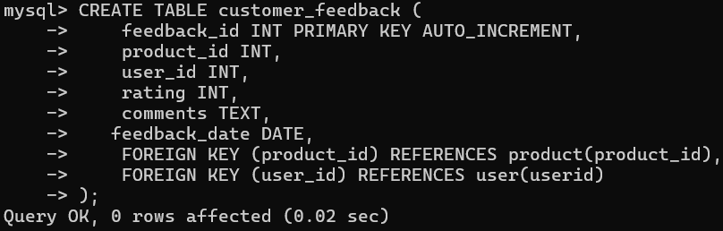

DROP TABLE customer_feedback;



1. ALTER TABLE DROP

ALTER TABLE payments DROP FOREIGN KEY payments_ibfk_1;

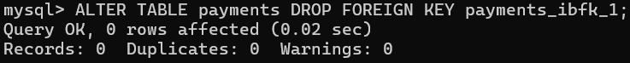

ALTER TABLE cart DROP FOREIGN KEY cart_ibfk_1;

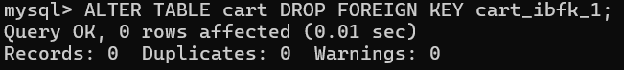

ALTER TABLE reviews DROP FOREIGN KEY reviews_ibfk_1;

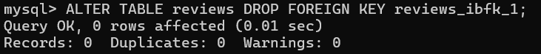

1. ALTER TABLE ADD:

ALTER TABLE orders ADD COLUMN status VARCHAR(20) DEFAULT 'Pending';



ALTER TABLE user ADD COLUMN email VARCHAR(255) NOT NULL;

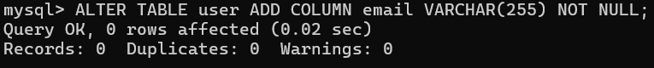

ALTER TABLE cart ADD CONSTRAINT fk_cart_product FOREIGN KEY (product_id) REFERENCES product(product_id);



1. Select Query for Single Table (including DISTINCT)

SELECT DISTINCT first_name FROM user;

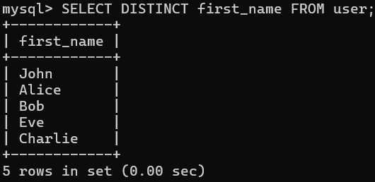

SELECT DISTINCT product_name FROM product;

SELECT DISTINCT payment_method FROM payments;

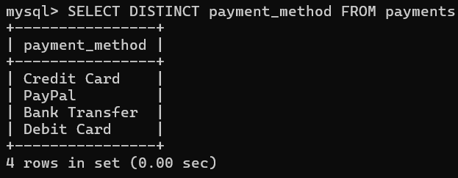

SELECT DISTINCT order_id FROM orders;

SELECT DISTINCT review_id FROM reviews;

SELECT DISTINCT cart_total FROM cart;

SELECT DISTINCT category_name FROM category;

SELECT DISTINCT supplier_id FROM supplier;

SELECT DISTINCT wishlist_id FROM wishlist;

1. WHERE claus:

SELECT * FROM user WHERE age > 25;

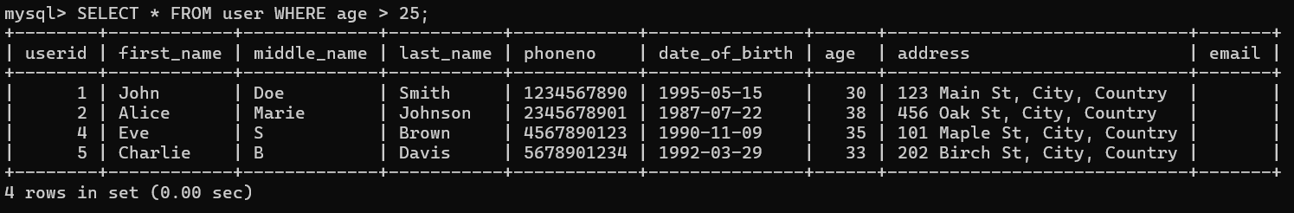

UPDATE product SET price = 75000 WHERE product_name = 'Laptop';



SELECT * FROM product WHERE category_id = (SELECT category_id FROM category WHERE category_name = 'Electronics');

SELECT * FROM orders WHERE price > 250;

SELECT * FROM reviews WHERE rating >= 4;

SELECT * FROM cart WHERE cart_total > 149;

SELECT * FROM supplier WHERE supplier_id = 2;

SELECT * FROM wishlist WHERE quantity_needed > 1;

1. Queries on Multiple Relations

SELECT orders.order_id, orders.product_name, orders.price, user.first_name, user.middle_name, user.last_name, user.email

FROM orders

JOIN user ON orders.user_id = user.userid;

SELECT product.product_id, product.product_name, product.price, category.category_name

FROM product

JOIN category ON product.category_id = category.category_id;

SELECT user.userid, user.first_name, user.last_name, user.email

FROM user

WHERE user.userid IN (SELECT reviews.user_id FROM reviews);

SELECT orders.order_id, orders.product_name, orders.price, users.first_name, users.middle_name, users.last_name, users.email

FROM orders

JOIN users ON orders.user_id = users.userid;

SELECT products.product_id, products.product_name, products.price, category.category_name

FROM products

JOIN category ON products.category_id = category.category_id;

SELECT users.userid, users.first_name, users.last_name, users.email

FROM users

WHERE users.userid IN (SELECT reviews.user_id FROM reviews);

SELECT cart.cart_id, cart.cart_total, products.product_name, products.price

FROM cart

JOIN products ON cart.product_id = products.product_id;

SELECT wishlist.wishlist_id, wishlist.product_name, products.product_name, wishlist.quantity_needed

FROM wishlist

JOIN products ON wishlist.product_id = products.product_id;

SELECT supplier.supplier_id, supplier.contact_info, products.product_name, products.price

FROM supplier

JOIN products ON supplier.product_id = products.product_id;

SELECT payments.payment_id, payments.payment_method, payments.amount, orders.order_id

FROM payments

JOIN orders ON payments.order_id = orders.order_id;

SELECT reviews.review_id, reviews.product_name, reviews.rating, users.first_name, users.last_name

FROM reviews

JOIN users ON reviews.user_id = users.userid;

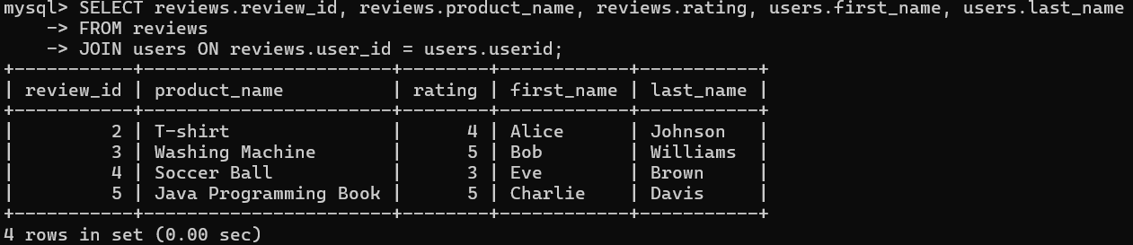

1. Natural Join

SELECT orders.order_id, orders.product_name, orders.price, user.first_name, user.last_name, user.email

FROM orders

NATURAL JOIN user;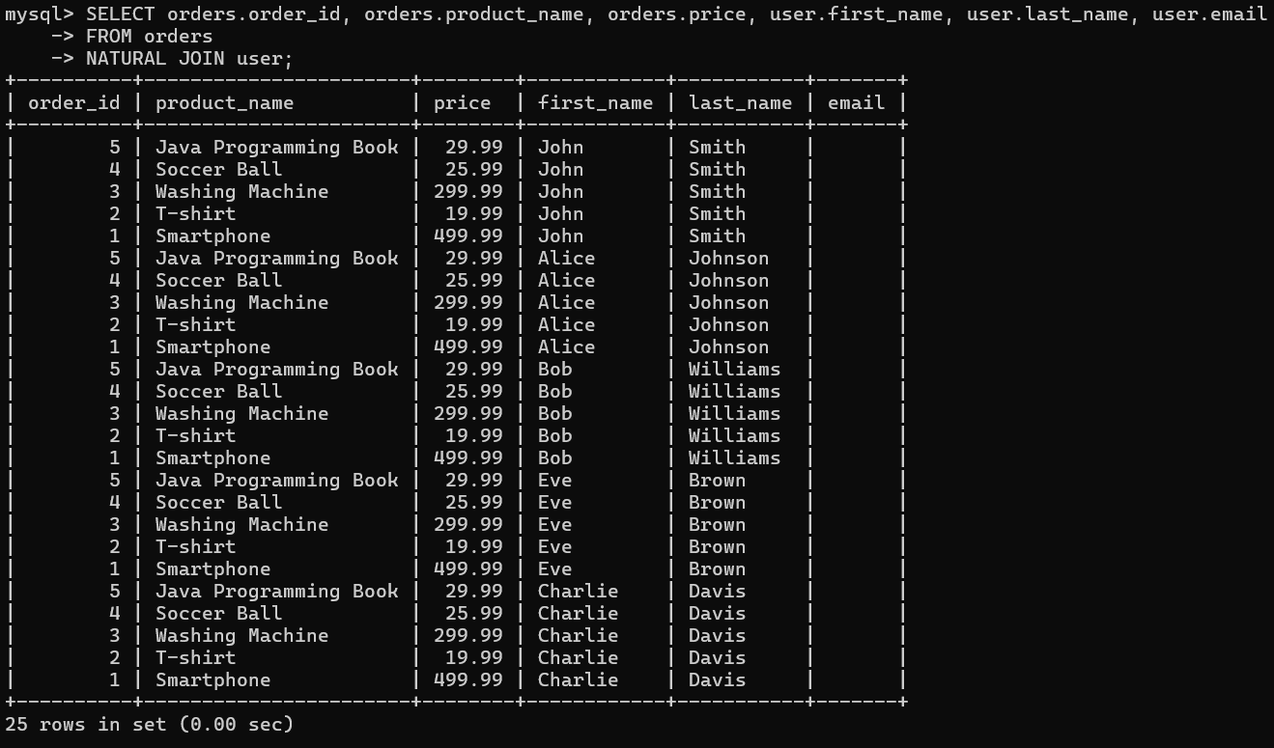

SELECT product.product_id, product.product_name, product.price, category.category_name

FROM product

NATURAL JOIN category;

SELECT reviews.review_id, reviews.product_name, reviews.rating, user.first_name, user.last_name

FROM reviews

NATURAL JOIN user;

SELECT cart.cart_id, cart.cart_total, products.product_name, products.price

FROM cart

NATURAL JOIN products;

SELECT wishlist.wishlist_id, wishlist.product_name, products.product_name, wishlist.quantity_needed

FROM wishlist

NATURAL JOIN products;

SELECT supplier.supplier_id, supplier.contact_info, products.product_name, products.price

FROM supplier

NATURAL JOIN products;

SELECT payments.payment_id, payments.payment_method, payments.amount, orders.order_id

FROM payments

NATURAL JOIN orders;

SELECT reviews.review_id, reviews.product_name, reviews.rating, users.first_name, users.last_name

FROM reviews

NATURAL JOIN users;

1. Rename Operation

RENAME TABLE user TO users;



RENAME TABLE orders TO order_details;



1. String Operation

SELECT CONCAT(first_name, ' ', last_name) AS full_name

FROM users;

SELECT UPPER(product_name) AS uppercase_product_name

FROM product;

SELECT CONCAT(first_name, ' ', middle_name, ' ', last_name) AS full_name

FROM users;

SELECT CONCAT(product_name, ' - ', category.category_name) AS product_category

FROM products

JOIN category ON products.category_id = category.category_id;

SELECT LOWER(payment_method) AS payment_method_lower

FROM payments;

SELECT LENGTH(product_name) AS product_name_length

FROM products;

SELECT SUBSTRING(product_name, 1, 5) AS product_name_substring

FROM products;

SELECT REPLACE(product_name, 'old', 'new') AS updated_product_name

FROM products;

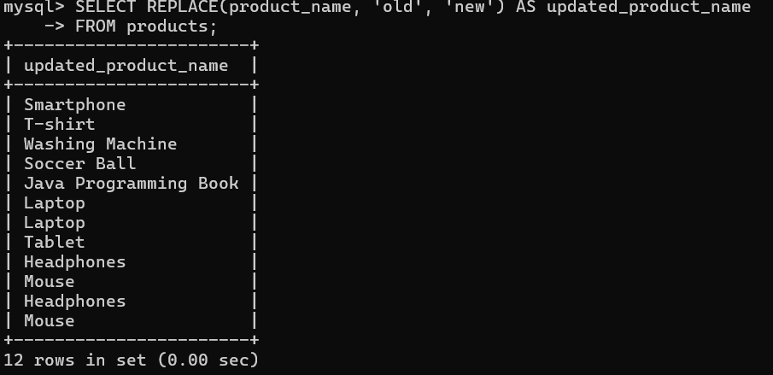

1. Order By Ascending

SELECT product_id, product_name, price

FROM product

ORDER BY price ASC;

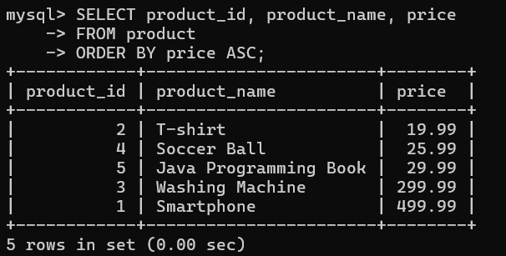

SELECT userid, first_name, last_name, email

FROM users

ORDER BY last_name ASC;

SELECT order_id, order_date, product_name, price

FROM order_details

ORDER BY order_date ASC;

SELECT payment_id, payment_method, amount

FROM payments

ORDER BY amount ASC;

SELECT order_id, product_name, quantity, price

FROM orders

ORDER BY price ASC;

SELECT review_id, product_name, rating

FROM reviews

ORDER BY rating ASC;

SELECT cart_id, cart_total, product_name

FROM cart

ORDER BY cart_total ASC;

SELECT category_id, category_name, description

FROM category

ORDER BY category_name ASC;

SELECT supplier_id, product_name, supplier_address

FROM supplier

ORDER BY supplier_id ASC;

SELECT product_id, product_name, price, quantity

FROM products

ORDER BY price ASC;

SELECT wishlist_id, product_name, quantity_needed

FROM wishlist

ORDER BY quantity_needed ASC;

1. Order By Descending

SELECT product_id, product_name, price

FROM products

ORDER BY price DESC;

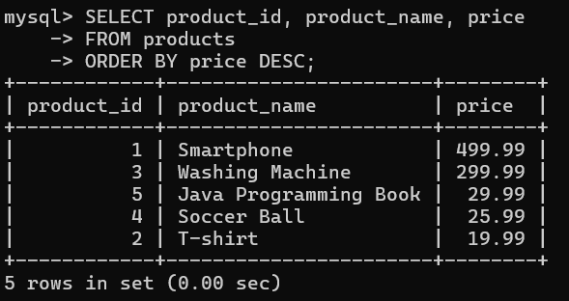

SELECT userid, first_name, last_name, email

FROM users

SELECT order_id, order_date, product_name, price

FROM order_details

ORDER BY order_date DESC;

SELECT order_id, price, order_date, product_name, quantity, user_id, status

FROM orders

ORDER BY price DESC;

SELECT payment_id, payment_method, amount, order_id

FROM payments

ORDER BY amount DESC;

SELECT review_id, product_name, user_id, rating

FROM reviews

ORDER BY rating DESC;

SELECT cart_id, cart_total, product_name, product_id, user_id

FROM cart

ORDER BY cart_total DESC;

SELECT category_id, category_name, description

FROM category

ORDER BY category_name DESC;

SELECT supplier_id, contact_info, product_id, product_name, supplier_address

FROM supplier

ORDER BY supplier_id DESC;

SELECT wishlist_id, product_id, product_name, quantity_needed, user_id

FROM wishlist

ORDER BY wishlist_id DESC;

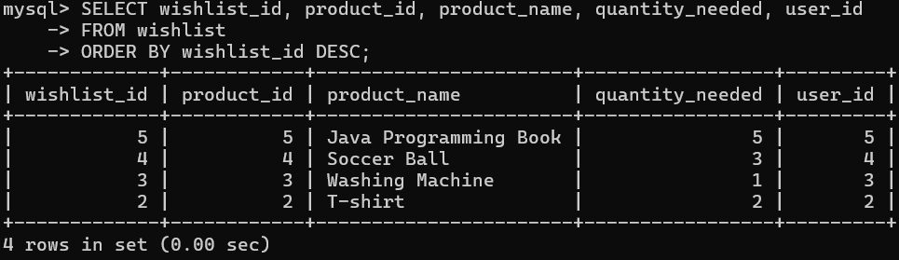

1. Where Clause Between

SELECT product_id, product_name, price

FROM products

WHERE price BETWEEN 0 AND 200;

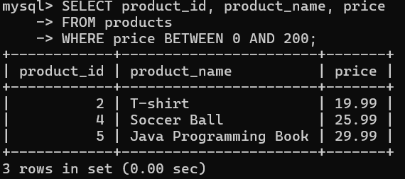

SELECT order_id, order_date, product_name, price

FROM order_details

WHERE order_date BETWEEN '2023-01-01' AND '2023-12-31';

SELECT userid, first_name, last_name, age

FROM users

WHERE age BETWEEN 20 AND 40;

SELECT order_id, price, order_date, product_name, quantity, user_id, status

FROM orders

WHERE price BETWEEN 100 AND 500;

SELECT payment_id, payment_method, amount, order_id

FROM payments

WHERE amount BETWEEN 50 AND 500;

SELECT review_id, product_name, user_id, rating

FROM reviews

WHERE rating BETWEEN 3 AND 5;

SELECT cart_id, cart_total, product_name, product_id, user_id

FROM cart

WHERE cart_total BETWEEN 0 AND 500;

SELECT category_id, category_name, description

FROM category

WHERE category_id BETWEEN 1 AND 5;

SELECT supplier_id, contact_info, product_id, product_name, supplier_address

FROM supplier

WHERE supplier_id BETWEEN 1 AND 10;

SELECT wishlist_id, product_id, product_name, quantity_needed, user_id

FROM wishlist

WHERE quantity_needed BETWEEN 4 AND 10;

1. Set Operations (UNION, INTERSECT, EXCEPT)

SELECT product_name FROM products

UNION

SELECT product_name FROM order_details;

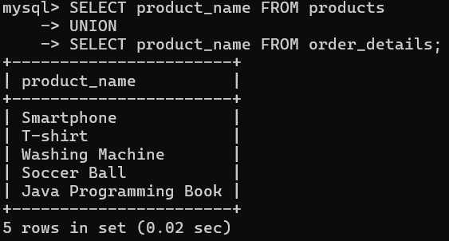

SELECT product_name FROM products

INTERSECT

SELECT product_name FROM order_details;

SELECT product_name FROM products

EXCEPT

SELECT product_name FROM order_details;

SELECT product_name FROM products

UNION

SELECT product_name FROM orders;

SELECT userid FROM users

INTERSECT

SELECT user_id FROM reviews;

SELECT product_name FROM products

EXCEPT

SELECT product_name FROM orders;

SELECT product_name FROM cart

UNION

SELECT product_name FROM wishlist;

SELECT category_id FROM category

INTERSECT

SELECT category_id FROM products;

SELECT product_name FROM supplier

EXCEPT

SELECT product_name FROM products;

SELECT order_id FROM orders

UNION

SELECT order_id FROM payments;

1. Aggregate Function

SELECT COUNT(*) AS total_products

FROM products;

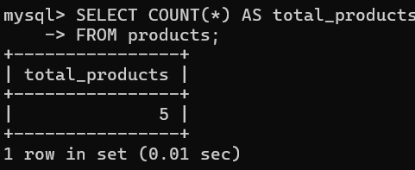

SELECT SUM(price) AS total_price

FROM products;

SELECT AVG(price) AS average_price

FROM products;

SELECT COUNT(*) AS total_orders

FROM orders;

SELECT SUM(price) AS total_order_value

FROM orders;

SELECT AVG(price) AS average_order_price

FROM orders;

SELECT COUNT(*) AS total_users

FROM users;

SELECT AVG(rating) AS average_rating

FROM reviews;

SELECT COUNT(*) AS total_wishlist_items

FROM wishlist;

SELECT COUNT(*) AS total_suppliers

FROM supplier;

1. Aggregate with Grouping
   1. COUNT with GROUP BY

SELECT product_name, COUNT(*) AS total_orders

FROM order_details

GROUP BY product_name;

* 1. SUM with GROUP BY

SELECT product_name, SUM(price) AS total_price

FROM orders

GROUP BY product_name;

* 1. AVG with GROUP BY

SELECT product_name, COUNT(*) AS total_orders

FROM orders

GROUP BY product_name;

SELECT category_id, COUNT(*) AS total_products

FROM products

GROUP BY category_id;

SELECT age, COUNT(*) AS total_users

FROM users

GROUP BY age;

SELECT user_id, COUNT(*) AS total_orders

FROM orders

GROUP BY user_id;

SELECT product_name, COUNT(*) AS total_wishlist_entries

FROM wishlist

GROUP BY product_name;

SELECT product_name, COUNT(*) AS total_suppliers

FROM supplier

GROUP BY product_name;

1. Having Clause

SELECT supplier_id, COUNT(*) AS total_products

FROM supplier

GROUP BY supplier_id

HAVING COUNT(*) > 0;

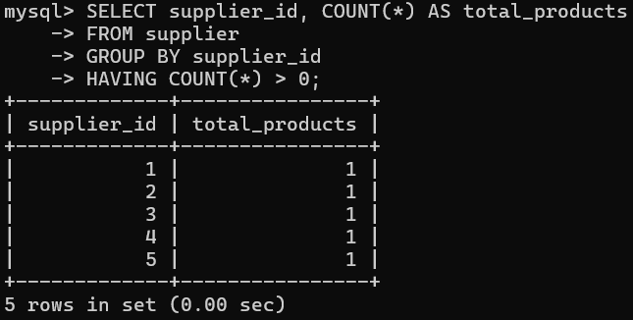

SELECT product_name, SUM(price) AS total_price

FROM order_details

GROUP BY product_name

HAVING SUM(price) > 100;

SELECT user_id, COUNT(*) AS total_orders

FROM orders

GROUP BY user_id

HAVING COUNT(*) > 0;

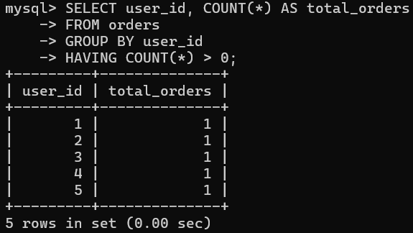

SELECT category_id, COUNT(*) AS total_products

FROM products

GROUP BY category_id

HAVING COUNT(*) > 5;

SELECT age, COUNT(*) AS total_users

FROM users

GROUP BY age

HAVING COUNT(*) > 0;

SELECT product_name, AVG(rating) AS average_rating

FROM reviews

GROUP BY product_name

HAVING AVG(rating) > 4;

SELECT product_name, COUNT(*) AS total_wishlist_entries

FROM wishlist

GROUP BY product_name

HAVING COUNT(*) > 0;

SELECT product_name, COUNT(*) AS total_orders

FROM orders

GROUP BY product_name

HAVING COUNT(*) > 1;

1. Nested Queries

SELECT product_name

FROM products

WHERE product_id IN (SELECT product_id FROM orders);

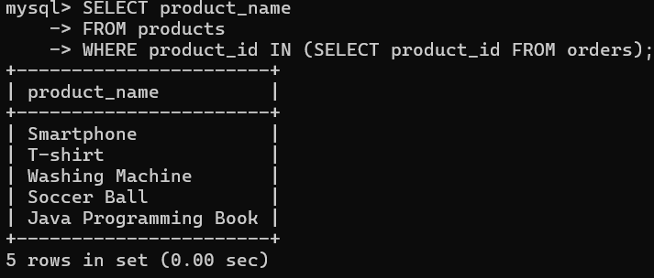

SELECT supplier_id

FROM supplier

WHERE EXISTS (SELECT 1 FROM cart WHERE supplier.product_id = cart.product_id);

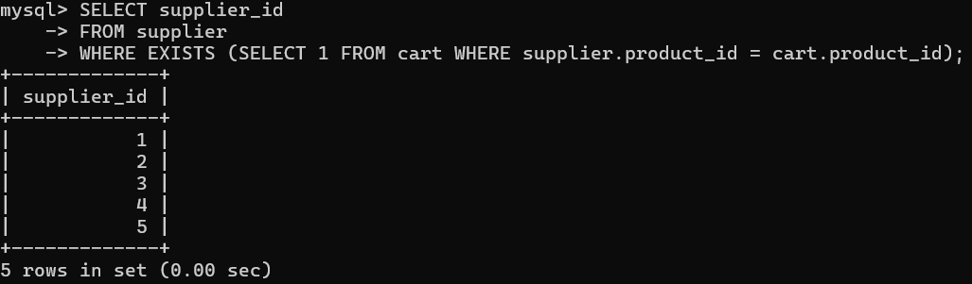

SELECT order_id

FROM orders

WHERE user_id IN (SELECT user_id FROM users WHERE age > 25);

SELECT userid

FROM users

WHERE EXISTS (SELECT 1 FROM orders WHERE users.userid = orders.user_id);

SELECT product_name

FROM reviews

WHERE product_name IN (SELECT product_name FROM reviews WHERE rating > 3);

SELECT cart_id

FROM cart

WHERE EXISTS (SELECT 1 FROM orders WHERE cart.product_id = orders.order_id);

SELECT product_name

FROM wishlist

WHERE product_id IN (SELECT product_id FROM orders);

SELECT supplier_id

FROM supplier

WHERE EXISTS (SELECT 1 FROM cart WHERE supplier.product_id = cart.product_id);

1. All Set Comparison (e.g., IN, ANY, ALL)
   1. IN

SELECT product_name

FROM products

WHERE product_id IN (SELECT product_id FROM cart);

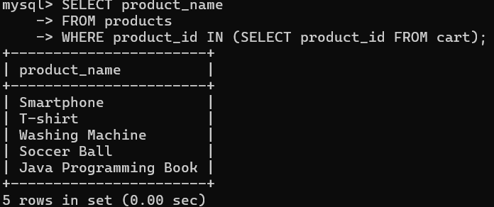

* 1. ANY

SELECT product_name

FROM products

WHERE price > ANY (SELECT price FROM products WHERE product_id IN (SELECT product_id FROM cart));

* 1. ALL

SELECT product_name

FROM products

WHERE price >= ALL (SELECT price FROM products WHERE product_id IN (SELECT product_id FROM cart));

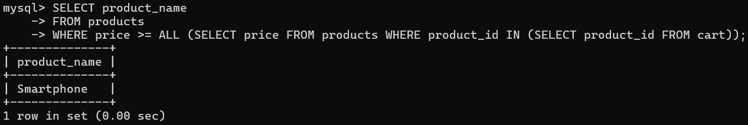

SELECT product_name

FROM orders

WHERE user_id IN (SELECT user_id FROM users WHERE age > 25);

SELECT first_name, last_name

FROM users

WHERE age > ANY (SELECT age FROM users WHERE userid IN (SELECT user_id FROM orders));

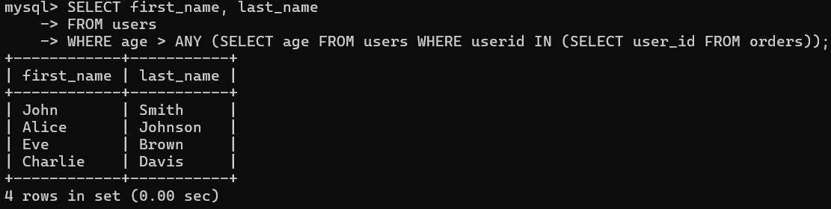

SELECT product_name

FROM reviews

WHERE rating >= ALL (SELECT rating FROM reviews WHERE user_id IN (SELECT user_id FROM orders));

1. With Clause

WITH OrderTotal AS (

SELECT o.order_id, p.product_name, o.quantity, (p.price * o.quantity) AS total_price

FROM orders o

JOIN products p ON o.product_name = p.product_name

)

SELECT order_id, product_name, total_price

FROM OrderTotal

WHERE total_price > 100;

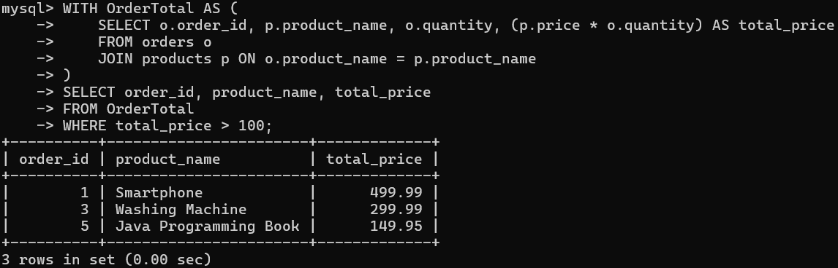

WITH ProductQuantities AS (

SELECT o.order_id, p.product_name, SUM(o.quantity) AS total_quantity

FROM orders o

JOIN products p ON o.product_name = p.product_name

GROUP BY o.order_id, p.product_name

)

SELECT order_id, product_name, total_quantity

FROM ProductQuantities

WHERE total_quantity > 2;

WITH UserOrders AS (

SELECT o.user_id, COUNT(*) AS total_orders

FROM orders o

GROUP BY o.user_id

)

SELECT u.userid, u.first_name, u.last_name, u.age, u.email, u.phoneno, u.address, u.date_of_birth, UserOrders.total_orders

FROM users u

JOIN UserOrders ON u.userid = UserOrders.user_id

WHERE UserOrders.total_orders > 0;

WITH ProductRatings AS (

SELECT product_name, AVG(rating) AS average_rating

FROM reviews

GROUP BY product_name

)

SELECT product_name, average_rating

FROM ProductRatings

WHERE average_rating > 0;

WITH UserCart AS (

SELECT user_id, SUM(cart_total) AS total_cart_value

FROM cart

GROUP BY user_id

)

SELECT u.userid, u.first_name, u.last_name, UserCart.total_cart_value

FROM users u

JOIN UserCart ON u.userid = UserCart.user_id

WHERE UserCart.total_cart_value > 150;

WITH UserWishlist AS (

SELECT user_id, COUNT(*) AS total_wishlist_items

FROM wishlist

GROUP BY user_id

)

SELECT u.userid, u.first_name, u.last_name, UserWishlist.total_wishlist_items

FROM users u

JOIN UserWishlist ON u.userid = UserWishlist.user_id

WHERE UserWishlist.total_wishlist_items > 0;

WITH SupplierProducts AS (

SELECT supplier_id, COUNT(*) AS total_products

FROM supplier

GROUP BY supplier_id

)

SELECT s.supplier_id, s.contact_info, s.supplier_address, SupplierProducts.total_products

FROM supplier s

JOIN SupplierProducts ON s.supplier_id = SupplierProducts.supplier_id

WHERE SupplierProducts.total_products > 0;

1. Scalar Queries

SELECT COUNT(*)

FROM orders;

SELECT AVG(price)

FROM products;

SELECT MAX(quantity)

FROM orders;

1. Update

UPDATE products

SET price = 99.99

WHERE product_name = 'T-shirt';

UPDATE orders

SET quantity = 5

WHERE order_id = 2;

UPDATE cart

SET cart_total = 150.75

WHERE cart_id = 3;

1. Types of Join (INNER, LEFT, RIGHT, FULL)
2. INNER JOIN

SELECT o.order_id, p.product_name, o.quantity

FROM orders o

INNER JOIN products p ON o.product_name = p.product_name;

1. LEFT JOIN

SELECT o.order_id, p.product_name, o.quantity

FROM orders o

LEFT JOIN products p ON o.product_name = p.product_name;

1. RIGHT JOIN

SELECT o.order_id, p.product_name, o.quantity

FROM orders o

RIGHT JOIN products p ON o.product_name = p.product_name;

1. FULL JOIN

SELECT o.order_id, p.product_name, o.quantity

FROM orders o

LEFT JOIN products p ON o.product_name = p.product_name

UNION

SELECT o.order_id, p.product_name, o.quantity

FROM orders o

RIGHT JOIN products p ON o.product_name = p.product_name;

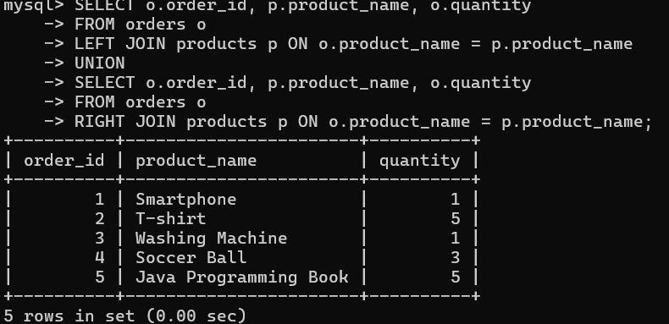

1. COMMIT

-- Start a new transaction

START TRANSACTION;

-- Insert a new record into the products table

INSERT INTO products (product_name, price)

VALUES ('Laptop', 999.99);

-- Insert a corresponding record into the orders table

INSERT INTO orders (product_name, quantity)

VALUES ('Laptop', 2);

-- Commit the transaction to save changes

COMMIT;

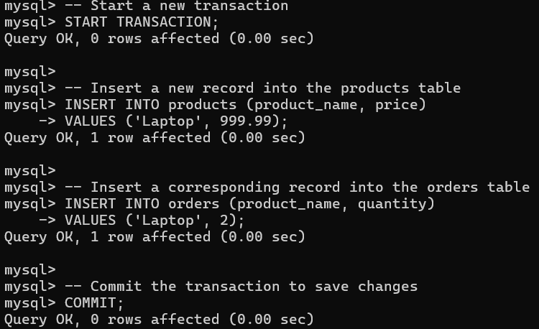

-- Start a new transaction

START TRANSACTION;

-- Update the product price for a specific product

UPDATE products

SET price = 89.99

WHERE product_name = 'T-shirt';

-- Insert a new order into the orders table

INSERT INTO orders (product_name, quantity)

VALUES ('Shoes', 3);

-- Commit the transaction to save changes

COMMIT;

1. ROLLBACK

-- Start a new transaction

START TRANSACTION;

-- Update the price of a product

UPDATE products

SET price = 79.99

WHERE product_name = 'T-shirt';

-- Simulate a mistake (you can decide to rollback)

-- Undo all changes made in this transaction

ROLLBACK;

-- Start a new transaction

START TRANSACTION;

-- Insert a new order into the orders table

INSERT INTO orders (product_name, quantity)

VALUES ('Shoes', 5);

-- You realize there's an error in the inserted data

-- Rollback to undo the insertion

ROLLBACK;

START TRANSACTION;

INSERT INTO products (product_name, price)

VALUES ('Smartphone', 499.99);

UPDATE products

SET price = 199.99

WHERE product_name = 'Laptop';

ROLLBACK;

1. SAVEPOINT

START TRANSACTION;

INSERT INTO products (product_name, price)

VALUES ('Tablet', 299.99);

SAVEPOINT after_insert;

UPDATE products

SET price = 149.99

WHERE product_name = 'Laptop';

ROLLBACK TO after_insert;

COMMIT;

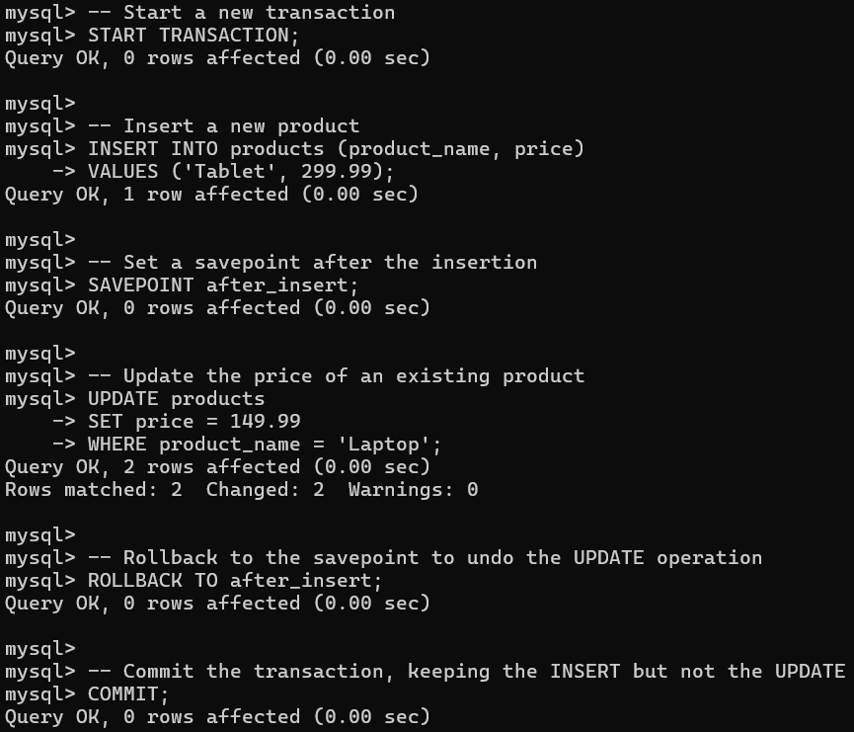

START TRANSACTION;

INSERT INTO products (product_name, price)

VALUES ('Headphones', 79.99);

SAVEPOINT after_first_insert;

INSERT INTO products (product_name, price)

VALUES ('Mouse', 25.99);

SAVEPOINT after_second_insert;

UPDATE products

SET price = 199.99

WHERE product_name = 'Laptop';

ROLLBACK TO after_second_insert;

COMMIT;

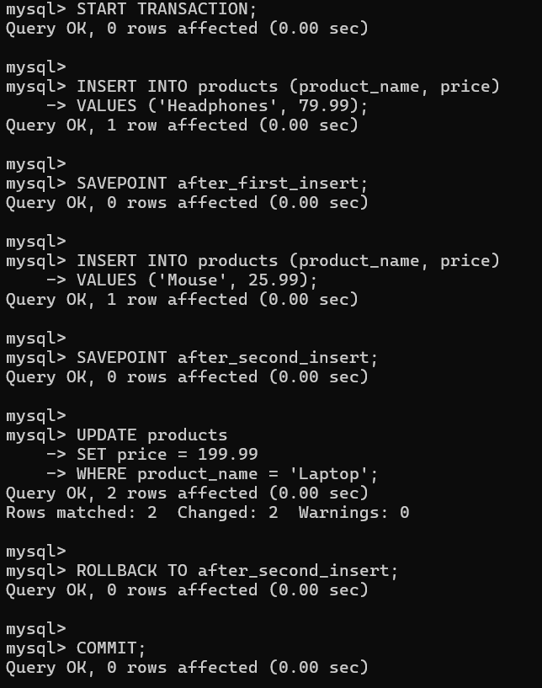

1. PL/SQL (Procedural Language in SQL)

DELIMITER $$

CREATE PROCEDURE GetUserDetails(IN u_id INT)

BEGIN

SELECT userid, first_name, middle_name, last_name, phoneno, date_of_birth, age, address

FROM users

WHERE userid = u_id;

END $$

DELIMITER ;

CALL GetUserDetails(1);

DELIMITER $$

CREATE FUNCTION GetCartTotal(u_id INT) RETURNS DECIMAL(10,2)

DETERMINISTIC

BEGIN

DECLARE total DECIMAL(10,2);

SELECT SUM(cart_total) INTO total

FROM cart

WHERE user_id = u_id;

RETURN total;

END $$

DELIMITER ;

SELECT GetCartTotal(1);

1. Cursor( Implicit)

DELIMITER $$

CREATE PROCEDURE GetProductDetails()

BEGIN

DECLARE v_product_name VARCHAR(100);

DECLARE v_product_price DECIMAL(10, 2);

DECLARE product_cursor CURSOR FOR

SELECT product_name, price

FROM products

WHERE product_id = 1;

DECLARE CONTINUE HANDLER FOR NOT FOUND SET @done = TRUE;

OPEN product_cursor;

read_loop: LOOP

FETCH product_cursor INTO v_product_name, v_product_price;

IF @done THEN

LEAVE read_loop;

END IF;

SELECT v_product_name AS Product_Name, v_product_price AS Product_Price;

END LOOP;

CLOSE product_cursor;

END $$

DELIMITER ;

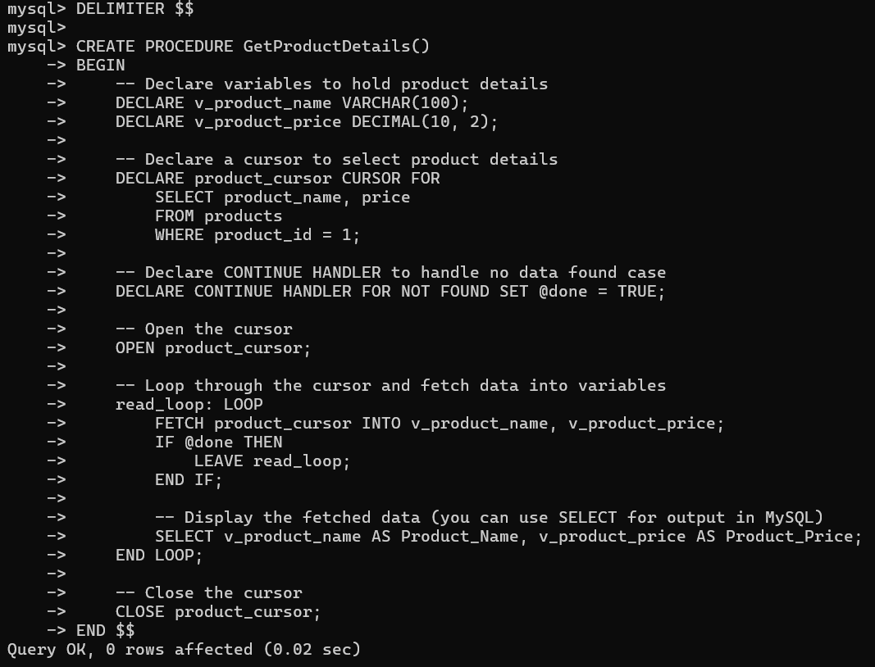

1. Cursor ( Explicit)

DELIMITER $$

CREATE PROCEDURE GetExplicitProductDetails()

BEGIN

DECLARE v_product_name VARCHAR(100);

DECLARE v_product_price DECIMAL(10, 2);

DECLARE product_cursor CURSOR FOR

SELECT product_name, price

FROM products

WHERE price > 50; -- You can change the condition as needed

DECLARE CONTINUE HANDLER FOR NOT FOUND SET @done = TRUE;

OPEN product_cursor;

read_loop: LOOP

FETCH product_cursor INTO v_product_name, v_product_price;

IF @done THEN

LEAVE read_loop;

END IF;

SELECT v_product_name AS Product_Name, v_product_price AS Product_Price;

END LOOP;

CLOSE product_cursor;

END $$

DELIMITER ;

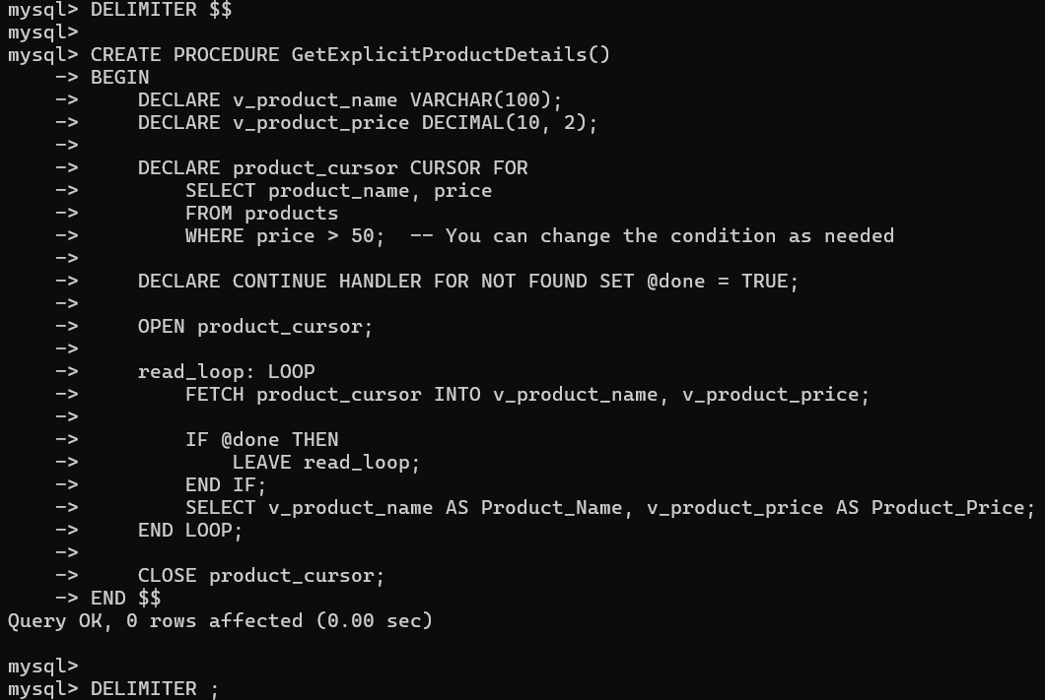

1. Triggers

DELIMITER $$

CREATE TRIGGER before_insert_product

BEFORE INSERT ON products

FOR EACH ROW

BEGIN

-- Check if the price is negative

IF NEW.price < 0 THEN

SIGNAL SQLSTATE '45000' SET MESSAGE_TEXT = 'Price cannot be negative';

END IF;

END $$

DELIMITER ;

DELIMITER $$

CREATE TRIGGER after_insert_product

AFTER INSERT ON products

FOR EACH ROW

BEGIN

INSERT INTO product_audit (product_id, product_name, action)

VALUES (NEW.product_id, NEW.product_name, 'INSERT');

END $$

DELIMITER ;

DELIMITER $$

CREATE TRIGGER before_update_product

BEFORE UPDATE ON products

FOR EACH ROW

BEGIN

-- Check if the new product name length is less than 5 characters

IF LENGTH(NEW.product_name) < 5 THEN

SIGNAL SQLSTATE '45000' SET MESSAGE_TEXT = 'Product name must be at least 5 characters long';

END IF;

END $$

DELIMITER ;

**Normalization**

1. Category: -

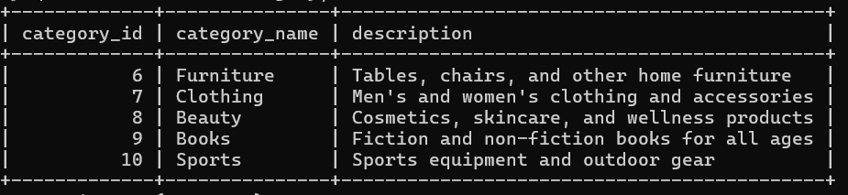

|  |  |  |
| --- | --- | --- |
| Normal Form | Status | Reason |
| 1NF | YES | All attributes are atomic |
| 2NF | YES | Fully functionally dependent on the primary key |
| 3NF | YES | No transitive dependencies |
| 4NF | YES | No multi-valued dependencies |
| 5NF | YES | No join dependencies |

Changes: - None — already normalized.

1. User : -

|  |  |  |
| --- | --- | --- |
| Normal Form | Status | Reason |
| 1NF | No | Contains multi-valued attribute: phone numbers |
| 2NF | No | Partial dependency exists (phone numbers are dependent on user_id, not on the primary key). |
| 3NF | No | Transitive dependency exists (phone numbers depend on user_id, but are not fully dependent on the primary key). |
| 4NF | No | Multi-valued dependency exists (phones) |
| 5NF | No | Data is not fully decomposed into the smallest possible parts. Data is not fully decomposed into the smallest possible parts. |

Changes: - We need to remove the phone1 and phone2 columns from the User table and store them separately in a new User_Phone table to resolve the multivalued column issue and move towards normalization.

After Normalization:

|  |  |  |
| --- | --- | --- |
| Normal Form | Status | Reason |
| 1NF | YES | no multivalued columns |
| 2NF | YES | No partial dependency (phone numbers moved to separate table). |
| 3NF | YES | No transitive dependency (phone numbers stored separately). |
| 4NF | YES | No multivalued dependency (phone numbers stored separately). |
| 5NF | YES | Table is decomposed into smallest parts (phone numbers in separate rows). |

1. Cart :-

|  |  |  |
| --- | --- | --- |
| Normal Form | Status | Reason |
| 1NF | YES | Atomic attributes |
| 2NF | YES | Fully functionally dependent on primary key |
| 3NF | YES | No transitive dependencies |
| 4NF | YES | No multi-valued dependencies |
| 5NF | YES | No join dependencies |

Changes: -No changes required

1. Orders:

|  |  |  |
| --- | --- | --- |
| Normal Form | Status | Reason |
| 1NF | YES | All values are atomic |
| 2NF | NO | product_name is partially dependent on order_id and user_id |
| 3NF | NO | product_name → product_id (transitive) |
| 4NF | YES | No multi-valued dependencies |
| 5NF | YES | Order data mixes product and user dependencies |

Changes: -

* Remove product_name and keep only product_id
* Ensure product details are fetched from Products table

|  |  |  |
| --- | --- | --- |
| Normal Form | Status | Reason |
| 1NF | YES | All values atomic |
| 2NF | YES | Full functional dependency on primary key |
| 3NF | YES | No transitive dependencies |
| 4NF | YES | No multi-valued dependencies |
| 5NF | YES | No join dependencies |

1. Supplier Table:

|  |  |  |
| --- | --- | --- |
| Normal Form | Status | Reason |
| 1NF | YES | All attributes are atomic |
| 2NF | NO | Contains product information that doesn't depend solely on supplier_id |
| 3NF | NO | Transitive dependency: product_name → product_id |
| 4NF | NO | One supplier can supply multiple products (multi-valued) |
| 5NF | NO | Product info should be in separate relation |

Changes: -

* + Remove product_name
  + Create a new table SupplierProduct to link suppliers and products

|  |  |  |
| --- | --- | --- |
| Normal From | Status | Reason |
| 1NF | YES | All atomic |
| 2NF | YES | Each attribute depends on full primary key |
| 3NF | YES | No transitive dependencies |
| 4NF | YES | No multi-valued dependencies |
| 5NF | YES | No join dependencies |

1. Payments:

|  |  |  |
| --- | --- | --- |
| Normal Form | Status | Reason |
| 1NF | YES | All attributes atomic |
| 2NF | YES | Fully functionally dependent on the primary key |
| 3NF | YES | No transitive dependencies |
| 4NF | YES | No multi-valued dependencies |
| 5NF | YES | No join dependencies |

Changes: - No changes required

1. Products:

|  |  |  |
| --- | --- | --- |
| Normal Form | Status | Reason |
| 1NF | YES | All values are atomic |
| 2NF | YES | Fully dependent on primary key |
| 3NF | NO | price and quantity might be updated together |
| 4NF | YES | No multi-valued dependency |
| 5NF | NO | Product details may need split if price varies by supplier |

Changes: -

* Move price and quantity to a table where stock can be tracked per supplier

|  |  |  |
| --- | --- | --- |
| Normal Form | Status | Reason |
| 1NF | YES | All atomic |
| 2NF | YES | All attributes depend on full primary key |
| 3NF | YES | No transitive dependencies |
| 4NF | YES | No multi-valued dependencies |
| 5NF | YES | No join dependencies |

1. Reviews:

|  |  |  |
| --- | --- | --- |
| Normal Form | Status | Reason |
| 1NF | YES | Atomic fields |
| 2NF | YES | Fully dependent on primary key |
| 3NF | YES | No transitive dependency |
| 4NF | YES | No multi-valued fields |
| 5NF | YES | No join dependency |

Changes: - No changes required.

1. WishList : -

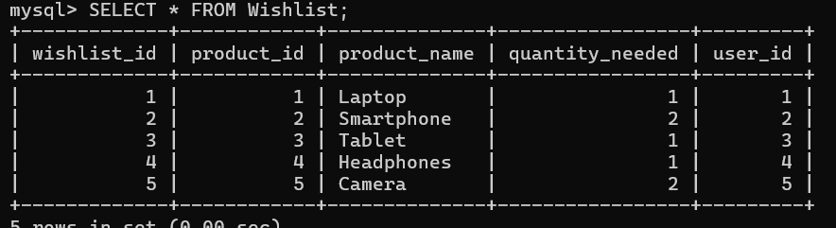

|  |  |  |
| --- | --- | --- |
| Normal Form | Status | Reason |
| 1NF | YES | Atomic attributes |
| 2NF | YES | Fully functionally dependent on primary key |
| 3NF | YES | No transitive dependencies |
| 4NF | YES | No multi-valued dependencies |
| 5NF | YES | No join dependencies |

Changes: - No changes required.